Crypt-Arithmetic Problem

Aim:
To solve the Crypt-Arithmetic Problem using Python by assigning unique digits to letters and finding a valid solution.

Objective:
- To implement the Crypt-Arithmetic Problem using Python.
- To assign unique digits to letters.
- To find a valid arithmetic solution.

Algorithm:
- Start.
- Read the crypt-arithmetic expression.
- Identify all unique letters.
- Generate possible digit assignments (0–9).
- Ensure each letter has a unique digit.
- Check whether the arithmetic equation is satisfied.
- If a valid solution is found, display it.
- Stop.
Flow chart:
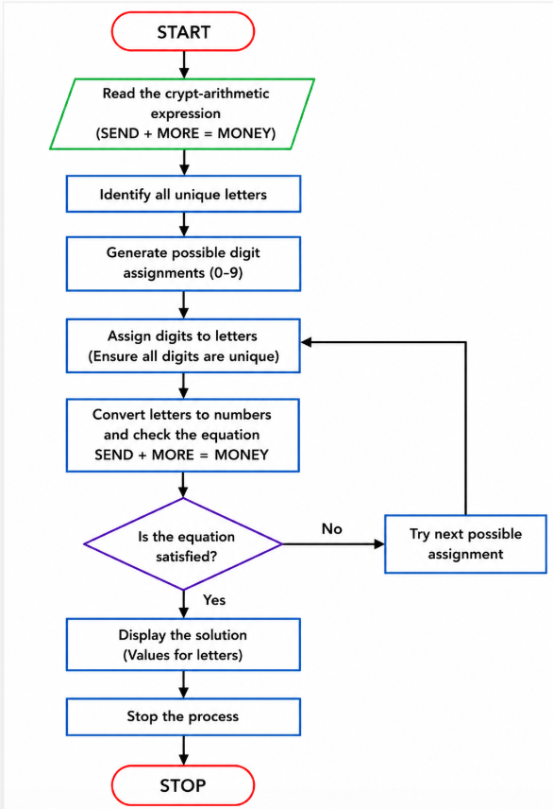
Code:
from itertools import permutations

letters = ('S', 'E', 'N', 'D', 'M', 'O', 'R', 'Y')

digits = range(10)

for perm in permutations(digits, len(letters)):
assign = dict(zip(letters, perm))

# Leading letters cannot be zero
if assign['S'] == 0 or assign['M'] == 0:
continue

SEND = (1000 * assign['S'] +
100 * assign['E'] +
10 * assign['N'] +
assign['D'])

MORE = (1000 * assign['M'] +
100 * assign['O'] +
10 * assign['R'] +
assign['E'])

MONEY = (10000 * assign['M'] +
1000 * assign['O'] +
100 * assign['N'] +
10 * assign['E'] +
assign['Y'])

if SEND + MORE == MONEY:
print("Solution Found!")
print("-----------------")
for key, value in assign.items():
print(f"{key} = {value}")

print("\nSEND =", SEND)
print("MORE =", MORE)
print("MONEY =", MONEY)
break
Output:
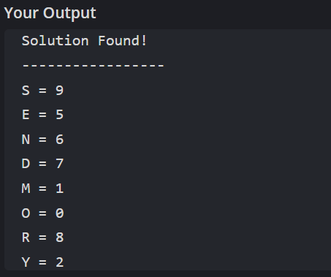
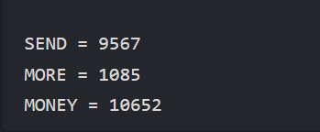
Result:
Thus, the Crypt-Arithmetic Problem was implemented successfully using Python, and a valid solution was obtained.

